DIALux – Use Light Centre Height when calculating Space

Calculating street lighting, Dialux will see the luminaire as one illuminated point.
The height to this point is denominated Light Centre Height. Furthermore Dialux uses Mounting Height denominating the top of the luminaire – as with interior lighting.

The Focus luminaires not being available in Dialux, they can only be imported to Dialux as ldt-files. You will get a wrong result if you let Dialux calculate the Light Centre Height based on the Mounting Height – example on the next page. Instead you should type the actual light centre height into the program in order to obtain the correct distance between poles.

Light Centre Height:
- Space at Ø60 pole: 183 mm + pole height
- Space at Ø76 pole: 183 mm + pole height + 32 mm

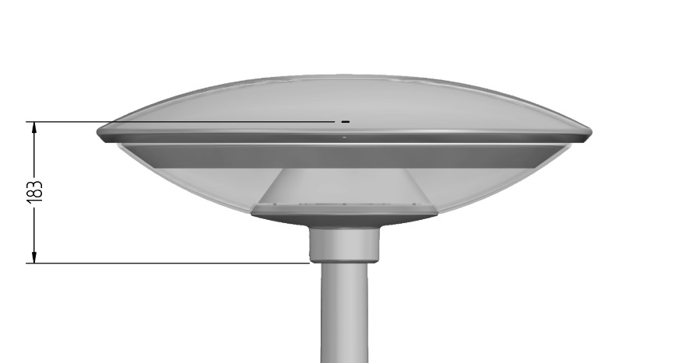

Typing the light centre height, you will see that the mounting height is wrong. However, this will not influence your calculation. If the pole height is 4 metres, you shall type the light centre height as 4.0 m + 183 mm = 4.183 m.

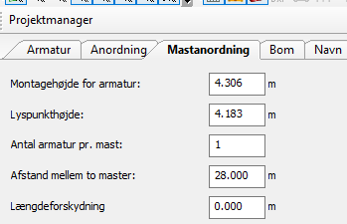

Why Dialux is incorrect:

In the case of Space the following dimensions of the luminaire are available for Dialux:

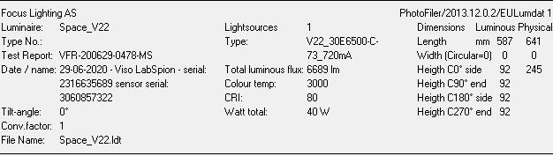

Example
As illustrated below, Dialux applies the dimensions incorrectly! If you type the mounting height, meaning the height to the top of the luminaire, f.ex. 4.0 m + 245 mm = 4.245 m, then the resulting light centre height will be 4.122 m, which is wrong. As shown in the previous page, the correct light centre height is 4.183 m.

